Serialisation – exemple

**public class Joueur{**



**public String nom;**

**public int age;**

**public Joueur(){**

**nom="";**

**age=0;**

**}**

**public Joueur(String _nom, int _age){**

**this.nom=_nom;**

**this.age=_age;**

**}**

**public void setNom(String _nom){**

**this.nom=_nom;**

**}**

**public String getNom(){**

**return this.nom;**

**}**

**public void setAge(int** **_age){**

**this.age=_age;**

**}**

**public int getAge(){**

**return this.age;**

**}**

**public String toString(){**

**return(nom+": "+age);**

|  |  |  |
| --- | --- | --- |
| **}** | **}** |  |
| 7 |  |

Exemple XML(1)

**public class SerXMLOut{**



**public static void main(String[]args){ try{**

**Joueur j1=new Joueur("Alice",12);**

**Joueur j2=new Joueur("Bob",14);**

**FileOutputStream fo=new FileOutputStream("Joueurs.xml");**

**XMLEncoder xe=new XMLEncoder(fo);**

**xe.writeObject(j1);**

**xe.writeObject(j2);**

**xe.close();**

**fo.close();**

**} catch(Exception e){**

**e.printStackTrace();**

**}**

**}**

**}**

**Attention : pour que cela marche il faut bien définir les getters et setters et mettre un constructeur vide dans la classe Joueur**

PR - SERIALISATION 8

Exemple XML(2)

**<?xml version="1.0" encoding="UTF-8"?>**

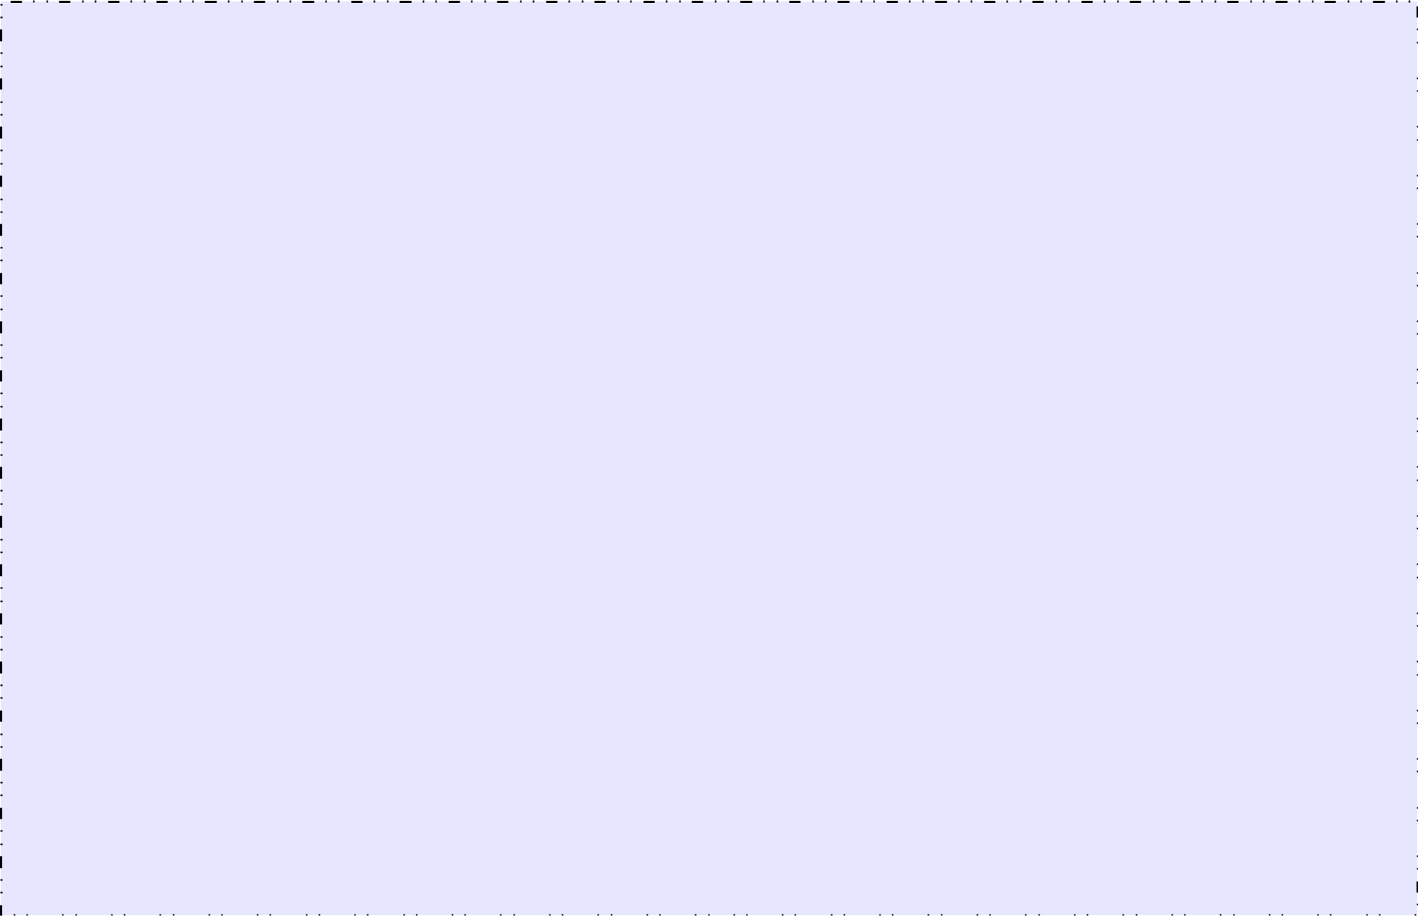

**<java version="12.0.2" class="java.beans.XMLDecoder">**

|  |  |  |  |  |  |  |  |  |  |  |  |  |  |  |  |  |  |  |  |  |  |  |  |  |  |  |  |  |  |  |  |  |  |  |  |  |  |  |  |  |  |  |  |  |  |  |  |  |  |  |  |  |  |  |  |  |  |  |  |  |  |
| --- | --- | --- | --- | --- | --- | --- | --- | --- | --- | --- | --- | --- | --- | --- | --- | --- | --- | --- | --- | --- | --- | --- | --- | --- | --- | --- | --- | --- | --- | --- | --- | --- | --- | --- | --- | --- | --- | --- | --- | --- | --- | --- | --- | --- | --- | --- | --- | --- | --- | --- | --- | --- | --- | --- | --- | --- | --- | --- | --- | --- | --- |
| **<object class="Joueur" id="Joueur0">** | | | | | | | | | | | | | | | | | | | | | | | | |  |  |  |  |  |  |  |  |  |  |  |  |  |  |  |  |  |  |  |  |  |  |  |  |  |  |  |  |  |  |  |  |  |  |  |  |  |
|  |  |  |  |  |  |  |  |  |  |  |  |  |  |  |  |  |  |  |  |  |  |  |  |  |  |  |  |  |  |  |  |  |  |  |  |  |
|  | **<void class="Joueur" method="getField">** | | | | | | | | | | | | | | | | | | | | | | | |  |  |  |  |  |  |  |  |  |  |  |  |  |  |  |  |  |  |  |  |  |  |  |  |  |  |  |  |  |  |  |  |  |  |  |  |  |
|  |  | **<string>nom</string>** | | | | | | | | | | | | | | | | | | | | | | |  |  |  |  |  |  |  |  |  |  |  |  |  |  |  |  |  |  |  |  |  |  |  |  |  |  |  |  |  |  |  |  |  |  |  |  |  |
|  |  |  |  |  |  |  |  |  |  |  |  |  |  |  |  |  |  |  |  |  |  |  |  |  |  |  |  |  |  |  |  |  |  |  |  |  |  |  |
|  |  | **<void method="set">** | | | | | | | | | | | | | | | | | | | | | | |  |  |  |  |  |  |  |  |  |  |  |  |  |  |  |  |  |  |  |  |  |  |  |  |  |  |  |  |  |  |  |  |  |  |  |  |  |
|  |  | **<object idref="Joueur0"/>** | | | | | | | | | | | | | | | | | | | | | | |  |  |  |  |  |  |  |  |  |  |  |  |  |  |  |  |  |  |  |  |  |  |  |  |  |  |  |  |  |  |  |  |  |  |  |  |  |
|  |  |  |  |  |  |  |  |  |  |  |  |  |  |  |  |  |  |  |  |  |  |  |  |  |  |  |  |  |  |  |  |  |  |  |  |  |  |  |
|  |  | **<string>Alice</string>** | | | | | | | | | | | | | | | | | | | | | | |  |  |  |  |  |  |  |  |  |  |  |  |  |  |  |  |  |  |  |  |  |  |  |  |  |  |  |  |  |  |  |  |  |  |  |  |  |
|  |  | **</void>** | | | | | | | | | | | | | | | | | | | | | | |  |  |  |  |  |  |  |  |  |  |  |  |  |  |  |  |  |  |  |  |  |  |  |  |  |  |  |  |  |  |  |  |  |  |  |  |  |
|  |  |  |  |  |  |  |  |  |  |  |  |  |  |  |  |  |  |  |  |  |  |  |  |  |  |  |  |  |  |  |  |  |  |  |  |  |  |  |
|  | **</void>** | | | | | | | | | | | | | | | | | | | | | | | |  |  |  |  |  |  |  |  |  |  |  |  |  |  |  |  |  |  |  |  |  |  |  |  |  |  |  |  |  |  |  |  |  |  |  |  |  |
|  | **<void class="Joueur" method="getField">** | | | | | | | | | | | | | | | | | | | | | | | |  |  |  |  |  |  |  |  |  |  |  |  |  |  |  |  |  |  |  |  |  |  |  |  |  |  |  |  |  |  |  |  |  |  |  |  |  |
|  |  |  |  |  |  |  |  |  |  |  |  |  |  |  |  |  |  |  |  |  |  |  |  |  |  |  |  |  |  |  |  |  |  |  |  |  |  |
|  |  | **<string>age</string>** | | | | | | | | | | | | | | | | | | | | | | |  | Fichiers joueurs.xml | | | | | | | | | | | | | | | | | | | | | | | | | | | | | | | | |  |  |  |
|  |  | **<void method="set">** | | | | | | | | | | | | | | | | | | | | | | |  |  |  |  |
|  |  |  |  |  |
|  |  | **<object idref="Joueur0"/>** | | | | | | | | | | | | | | | | | | | | | | |  |  |  |  |  |  |  |  |  |  |  |  |  |  |  |  |  |  |  |  |  |  |  |  |  |  |  |  |  |  |  |  |  |  |  |  |  |
|  |  |  |  |  |  |  |  |  |  |  |  |  |  |  |  |  |  |  |  |  |  |  |  |  |  |  |  |  |  |  |  |  |  |  |  |  |  |  |
|  |  | **<int>12</int>** | | | | | | | | | | | | | | | | | | | | | | |  |  |  |  |  |  |  |  |  |  |  |  |  |  |  |  |  |  |  |  |  |  |  |  |  |  |  |  |  |  |  |  |  |  |  |  |  |
|  |  | **</void>** | | | | | | | | | | | | | | | | | | | | | | |  |  |  |  |  |  |  |  |  |  |  |  |  |  |  |  |  |  |  |  |  |  |  |  |  |  |  |  |  |  |  |  |  |  |  |  |  |
|  |  |  |  |  |  |  |  |  |  |  |  |  |  |  |  |  |  |  |  |  |  |  |  |  |  |  |  |  |  |  |  |  |  |  |  |  |  |  |
|  | **</void>** | | | | | | | | | | | | | | | | | | | | | | | |  |  |  |  |  |  |  |  |  |  |  |  |  |  |  |  |  |  |  |  |  |  |  |  |  |  |  |  |  |  |  |  |  |  |  |  |  |
| **</object>** | | | | | | | | | | | | | | | | | | | | | | | | |  |  |  |  |  |  |  |  |  |  |  |  |  |  |  |  |  |  |  |  |  |  |  |  |  |  |  |  |  |  |  |  |  |  |  |  |  |
|  |  |  |  |  |  |  |  |  |  |  |  |  |  |  |  |  |  |  |  |  |  |  |  |  |  |  |  |  |  |  |  |  |  |  |  |  |
| **<object class="Joueur" id="Joueur1">** | | | | | | | | | | | | | | | | | | | | | | | | |  |  |  |  |  |  |  |  |  |  |  |  |  |  |  |  |  |  |  |  |  |  |  |  |  |  |  |  |  |  |  |  |  |  |  |  |  |
|  | **<void class="Joueur" method="getField">** | | | | | | | | | | | | | | | | | | | | | | | |  |  |  |  |  |  |  |  |  |  |  |  |  |  |  |  |  |  |  |  |  |  |  |  |  |  |  |  |  |  |  |  |  |  |  |  |  |
|  |  |  |  |  |  |  |  |  |  |  |  |  |  |  |  |  |  |  |  |  |  |  |  |  |  |  |  |  |  |  |  |  |  |  |  |  |  |
|  |  | **<string>nom</string>** | | | | | | | | | | | | | | | | | | | | | | |  |  |  |  |  |  |  |  |  |  |  |  |  |  |  |  |  |  |  |  |  |  |  |  |  |  |  |  |  |  |  |  |  |  |  |  |  |
|  |  | **<void method="set">** | | | | | | | | | | | | | | | | | | | | | | |  |  |  |  |  |  |  |  |  |  |  |  |  |  |  |  |  |  |  |  |  |  |  |  |  |  |  |  |  |  |  |  |  |  |  |  |  |
|  |  |  |  |  |  |  |  |  |  |  |  |  |  |  |  |  |  |  |  |  |  |  |  |  |  |  |  |  |  |  |  |  |  |  |  |  |  |  |
|  |  | **<object idref="Joueur1"/>** | | | | | | | | | | | | | | | | | | | | | | |  |  |  |  |  |  |  |  |  |  |  |  |  |  |  |  |  |  |  |  |  |  |  |  |  |  |  |  |  |  |  |  |  |  |  |  |  |
|  |  | **<string>Bob</string>** | | | | | | | | | | | | | | | | | | | | | | |  |  |  |  |  |  |  |  |  |  |  |  |  |  |  |  |  |  |  |  |  |  |  |  |  |  |  |  |  |  |  |  |  |  |  |  |  |
|  |  |  |  |  |  |  |  |  |  |  |  |  |  |  |  |  |  |  |  |  |  |  |  |  |  |  |  |  |  |  |  |  |  |  |  |  |  |  |
|  |  | **</void>** | | | | | | | | | | | | | | | | | | | | | | |  |  |  |  |  |  |  |  |  |  |  |  |  |  |  |  |  |  |  |  |  |  |  |  |  |  |  |  |  |  |  |  |  |  |  |  |  |
|  | **</void>** | | | | | | | | | | | | | | | | | | | | | | | |  |  |  |  |  |  |  |  |  |  |  |  |  |  |  |  |  |  |  |  |  |  |  |  |  |  |  |  |  |  |  |  |  |  |  |  |  |
|  |  |  |  |  |  |  |  |  |  |  |  |  |  |  |  |  |  |  |  |  |  |  |  |  |  |  |  |  |  |  |  |  |  |  |  |  |  |
|  |  |  |  |  |  |  |  |  |  |  |  |  |  |  |  |  |  |  |  |  |  |  |  |  |  |  |  |  |  |  |  |  |  |  |  |  |  |
|  | **<void class="Joueur" method="getField">** | | | | | | | | | | | | | | | | | | | | | | | |  |  |  |  |  |  |  |  |  |  |  |  |  |  |  |  |  |  |  |  |  |  |  |  |  |  |  |  |  |  |  |  |  |  |  |  |  |
|  |  | **<string>age</string>** | | | | | | | | | | | | | | | | | | | | | | |  |  |  |  |  |  |  |  |  |  |  |  |  |  |  |  |  |  |  |  |  |  |  |  |  |  |  |  |  |  |  |  |  |  |  |  |  |
|  |  |  |  |  |  |  |  |  |  |  |  |  |  |  |  |  |  |  |  |  |  |  |  |  |  |  |  |  |  |  |  |  |  |  |  |  |  |  |
|  |  |  |  |  |  |  |  |  |  |  |  |  |  |  |  |  |  |  |  |  |  |  |  |  |  |  |  |  |  |  |  |  |  |  |  |  |  |  |
|  |  | **<void method="set">** | | | | | | | | | | | | | | | | | | | | | | |  |  |  |  |  |  |  |  |  |  |  |  |  |  |  |  |  |  |  |  |  |  |  |  |  |  |  |  |  |  |  |  |  |  |  |  |  |
|  |  | **<object idref="Joueur1"/>** | | | | | | | | | | | | | | | | | | | | | | |  |  |  |  |  |  |  |  |  |  |  |  |  |  |  |  |  |  |  |  |  |  |  |  |  |  |  |  |  |  |  |  |  |  |  |  |  |
|  |  |  |  |  |  |  |  |  |  |  |  |  |  |  |  |  |  |  |  |  |  |  |  |  |  |  |  |  |  |  |  |  |  |  |  |  |  |  |
|  |  |  |  |  |  |  |  |  |  |  |  |  |  |  |  |  |  |  |  |  |  |  |  |  |  |  |  |  |  |  |  |  |  |  |  |  |  |  |
|  |  | **<int>14</int>** | | | | | | | | | | | | | | | | | | | | | | |  |  |  |  |  |  |  |  |  |  |  |  |  |  |  |  |  |  |  |  |  |  |  |  |  |  |  |  |  |  |  |  |  |  |  |  |  |
|  |  | **</void>** | | | | | | | | | | | | | | | | | | | | | | |  |  |  |  |  |  |  |  |  |  |  |  |  |  |  |  |  |  |  |  |  |  |  |  |  |  |  |  |  |  |  |  |  |  |  |  |  |
|  |  |  |  |  |  |  |  |  |  |  |  |  |  |  |  |  |  |  |  |  |  |  |  |  |  |  |  |  |  |  |  |  |  |  |  |  |  |  |
|  |  |  |  |  |  |  |  |  |  |  |  |  |  |  |  |  |  |  |  |  |  |  |  |  |  |  |  |  |  |  |  |  |  |  |  |  |  |  |
|  | **</void>** | | | | | | | | | | | | | | | | | | | | | | | |  |  |  |  |  |  |  |  |  |  |  |  |  |  |  |  |  |  |  |  |  |  |  |  |  |  |  |  |  |  |  |  |  |  |  |  |  |
| **</object>** | | | | | | | | | | | | | | | | | | | | | | | | |  |  |  |  |  |  |  |  |  |  |  |  |  |  |  |  |  |  |  |  |  |  |  |  |  |  |  |  |  |  |  |  |  |  |  |  |  |
|  |  |  |  |  |  |  |  |  |  |  |  |  |  |  |  |  |  |  |  |  |  |  |  |  |  |  |  |  |  |  |  |  |  |  |  |  |
| **</java>** | | | | | | | | | | | | | | | | | | | | | | | | |  |  |  |  |  |  |  |  |  |  |  |  |  |  |  |  |  |  |  |  |  |  |  |  |  |  |  |  |  |  |  |  |  |  | 9 | |  |
|  | | | | | | | | | | | | | | | | | | | | | | | | | | | | | | | | | | | | | | | | | | | | | | | | | | | | | | | | | | |  |
|  |  |  |  |  |  |  |  |  |  |  |  |  |  |  |  |  |  |  |  |  |  |  |  |  |  |  |  |  |  |  |  |  |  |  |  |  |  |  |  |  |  |  |  |  |  |  |  |  |  |  |  |  |  |  |  |  |  |  | | |  |

Exemple XML(3)

**public class SerXMLIn{**



**public static void main(String[]args){ try{**

**Joueur j=null;**

**FileInputStream fi=new FileInputStream("Joueurs.xml"); XMLDecoder xd=new XMLDecoder(fi); try{**

**j=(Joueur)xd.readObject();**

**while(true){**

**System.out.println(j.toString());**

**j=(Joueur)xd.readObject();**

**}**

**}catch(ArrayIndexOutOfBoundsException aie){ //Fin du parsing**

**}**

**xd.close();**

**fi.close();**

**}catch(Exception e){**

**e.printStackTrace();**

**}**

**}**

**}**

PR - SERIALISATION 10

Le stockage dans un fichier

* Sérialiser dans un fichier en Java
  + Déclarer les objets que l'on sérialise comme implémentant l'interface Serializable
  + On peut ensuite écrire des objets grâce à des flux d'écriture d'objets
    - Classe **ObjectOutputStream**

– Méthode **void writeObject(Object o)**

– Si l'objet ou un des objets appartenant à ces champs n'est pas sérialisable, une exception est levée

* + Pour lire les objets
    - Classe **ObjectInputStream**

– Méthode **Object readObject(**)

– Il faut caster l'objet dans la classe désirée

PR - SERIALISATION 11

Exemple (1)

**import java.io.*;**



**public class Personne implements Serializable{**

**private String nom;**

**private Chien chien;**

**public Personne(String _nom,Chien_chien){**

**this.nom=_nom;**

**this.chien=_chien;**

**}**

**public String toString(){**

**return (nom+", "+chien.toString());**

**}**

**public Chien getChien(){**

**return chien;**

**}**

**}**

PR - SERIALISATION 12

Exemple (2)

**import java.io.*;**



**public class Chien implementsSerializable{**

**private String nom;**

**public Chien(String _nom){**

**this.nom=_nom;**

**}**

**public String toString(){**

**return nom;**

**}**

**}**

PR - SERIALISATION 13

Exemple (3)

**import java.io.*;**



**public class SerOut{**

**public static void main(String[]args){**

**try{**

**Chien c1=new Chien("Laika");**

**Personne p1=new Personne("Alice",c1);**

**Personne p2=new Personne("Bob",c1);**

**Personne p3=new Personne("Charles",c1);**

**FileOutputStream fo=new FileOutputStream("PersonneObj.bin");**

**ObjectOutputStream os=new ObjectOutputStream(fo);**

**os.writeObject(p1);**

**os.writeObject(p2);**

**os.writeObject(p3);**

**os.close();**

**fo.close();**

**} catch(Exception e){**

**e.printStackTrace();**

**}**

**}**

**}**

PR - SERIALISATION 14

Exemple (4)

**import java.io.*;**



**public class SerIn{**

**public static voidmain(String[]args){**

**try{**

**Personne p=null;**

**FileInputStream fi=new FileInputStream("PersonneObj.bin"); ObjectInputStream ois=new ObjectInputStream(fi);**

**try{**

**while(true){**

**p=(Personne)ois.readObject();**

**System.out.println(p.toString());**

**}**

**}catch(EOFException eof){**

**//Fin du fichier**

**}**

**ois.close();**

**fi.close();**

**} catch(Exception e){**

**e.printStackTrace();**

**}**

**}**

**}**

PR - SERIALISATION 15

Exemple (4)

**import java.io.*;**



**public class SerIn{**

**public static voidmain(String[]args){**

**try{**

**Personne p=null;**

**FileInputStream fi=new FileInputStream("PersonneObj.bin"); ObjectInputStream ois=new ObjectInputStream(fi);**

**try{**

**while(true){**

**p=(Personne)ois.readObject();**

**System.out.println(p.toString());**

**}**

**} catch(EOFException eof){**

**//Fin du fichier**

**}**

**ois.close();**

**fi.close();**

**} catch(Exception e){**

**e.printStackTrace();**

**}**

**}**

**}**

PR - SERIALISATION 16

Exemple (5)

**public class SerIn2{**

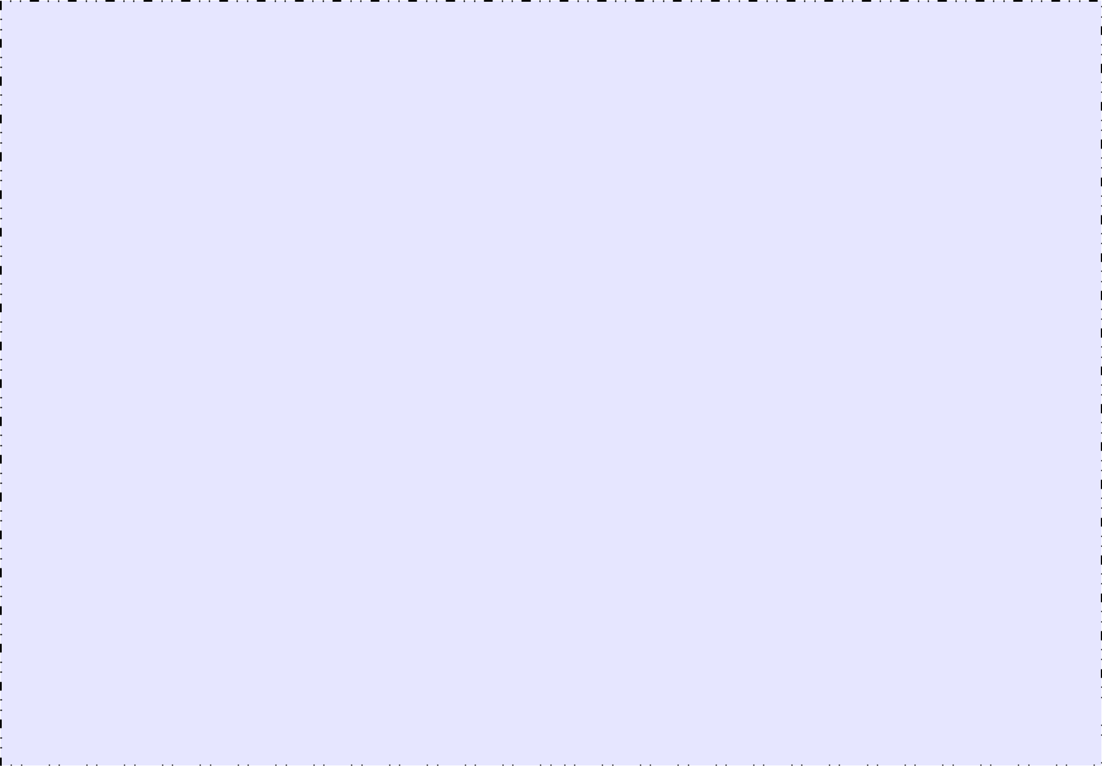

**public static voidmain(String[]args){**

**try{**

**Personne p1=null;**

**Personne p2=null;**

**Personne p3=null;**

**FileInputStream fi=new FileInputStream("PersonneObj.bin"); ObjectInputStream ois=new ObjectInputStream(fi);**

**try{**

**p1=(Personne)ois.readObject();**

**p2=(Personne)ois.readObject();**

**p3=(Personne)ois.readObject();**

**if(p1.getChien()==p2.getChien()){**

**System.out.println("Même chien");**

**}**

**} catch(EOFException eof){**

**//Fin du fichier**

**}**

**ois.close();**

**fi.close();**

**} catch(Exception e){**

**e.printStackTrace();**

**}**

**}**

|  |  |  |  |  |  |  |  |  |  |  |  |  |  |  |  |  |  |  |  |  |  |  |  |  |  |  |  |  |  |  |  |  |  |  |  |  |  |  |  |  |  |  |  |  |  |  |  |  |  |  |  |  |  |  |  |  |  |  |  |  |
| --- | --- | --- | --- | --- | --- | --- | --- | --- | --- | --- | --- | --- | --- | --- | --- | --- | --- | --- | --- | --- | --- | --- | --- | --- | --- | --- | --- | --- | --- | --- | --- | --- | --- | --- | --- | --- | --- | --- | --- | --- | --- | --- | --- | --- | --- | --- | --- | --- | --- | --- | --- | --- | --- | --- | --- | --- | --- | --- | --- | --- |
| **}** |  |  |  |  |  |  |  |  |  |  |  |  |  |  |  |  |  |  |  |  |  |  |  |  |  |  |  |  | 17 | | | | | | | | | | | | | | | | | | | | | | | | | | | | | |  |  |
|  |  |  |  |  |  |  |  |  |  |  |  |  |  |  |  |  |  |  |  |  |  |  |  |  |  |  |  |  |  |
|  |  |  |  |  |  |  |  |  |  |  |  |  |  |  |  |  |  |  |  |  |  |  |  |  |  |  |  |  |  |
|  | | | | | | | | | | | | | | | | | | | | | | | | | | | | | | | | | | | | | | | | | | | | | | | | | | | | | | | | | | |  |
|  | | | | | | | | | | | | | | | | | | | | | | | | | | | | | | | | | | | | | | | | | | | | | | | | | | | | | | | | | | | |  |
|  |  |  |  |  |  |  |  |  |  |  |  |  |  |  |  |  |  |  |  |  |  |  |  |  |  |  |  |  |  |  |  |  |  |  |  |  |  |  |  |  |  |  |  |  |  |  |  |  |  |  |  |  |  |  |  |  |  |  | |  |

Sérialiser que certains champs

* Il est possible de préciser qu'au moment de la sérialisation, on ne souhaite pas retenir certains champs d'un objet
  + On utilise le mot clef **transient**
  + L'information contenue dans ces champs ne sera pas enregistré au moment de la sérialisation
* Au moment de la désérialisation, ces champs sont mis à **null**
  + **ATTENTION** aux NullPointerException

PR - SERIALISATION 18

Exemple

**import java.io.*;**



**public class Personne implements Serializable{**

**private String nom;**

**private transient Chien chien;**

**public Personne(String _nom,Chien_chien){**

**this.nom=_nom;**

**this.chien=_chien;**

**}**

**public String toString(){**

**return(nom+", "+chien.toString());**

**}**

**public Chien getChien(){**

**return chien;**

**}**

**}**

PR - SERIALISATION 19

Gestion de versions de classe

**import java.io.*;**



**public class Personne2 implements Serializable{**

**private String nom;**

**int age;**

**private static final long serialVersionUID=1;**

**public Personne2(String _nom,int_age){**

**this.nom=_nom;**

**this.age=_age;**

**}**

**public String toString(){**

**return(nom+", "+age);**

**}**

**}**

PR - SERIALISATION 22

Sérialisation personnalisée

* Il est également possible de personnaliser la façon dont un objet est sérialisé
* Par exemple, pour omettre certains champs ou rajouter de l'information
* Pour cela il faut que l'objet à sérialiser implémente les méthodes :
  + **private void readObject(ObjectInputStream ois) throws IOException, ClassNotFoundException**
  + **private void writeObject(ObjectOutptStream oos) throws IOException**
* Ces méthodes sont appelées lors de la désérialisation et de la sérialisation
* Attention, il faut que l'ordre dans lequel on lit les informations soit le même que l'ordre dans lequel on écrit

PR - SERIALISATION 23

Exemple

**public class Personne3 implements Serializable{**

**private String nom;**

**int age;**

**int num;**

**public Personne3(String _nom,int _age,int_num){**

**this.nom=_nom;**

**this.age=_age;**

**this.num=_num;**

**}**

**private void readObject(ObjectInputStream ois) throws IOException, ClassNotFoundException {**

**nom=(String)ois.readObject();**

**age=ois.readInt();**

**}**

**private void writeObject(ObjectOutputStream oos)** **throws IOException{**

**oos.writeObject(nom);**

**oos.writeInt(age);**

**}**

**public String toString(){**

**return(nom+", "+age+", "+num);**

**}**

**}**

24